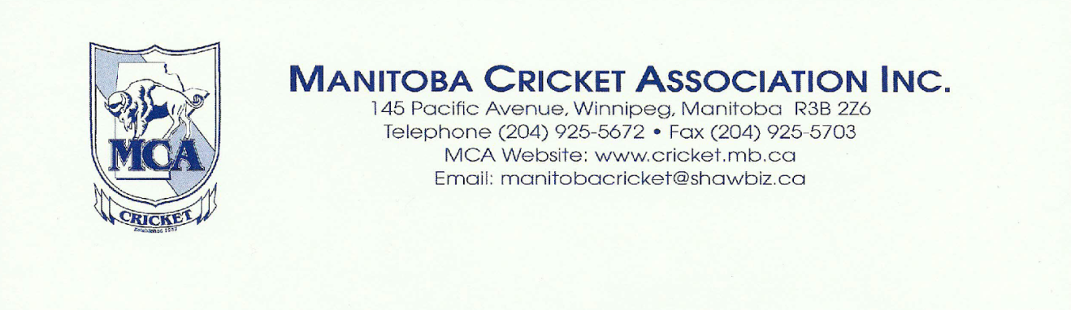

April 12, 2018

To: All Clubs / Teams and Executive Members

From: Shoib Khan, MCA Senior Summer League Secretary

The MCA 2nd Senior Summer League Meeting will be held on Sunday April 15, 2018 from 10:00 a.m. – 1:30 p.m. at Sport Manitoba, 145 Pacific Avenue in the Conference Room B.

Please send one representative from your team along with your second league payment of $1,000. Wednesday, Evening Recreational teams are to bring a second payment of $500.00. These payments will be applied towards your team’s 2018 league fees. These payments are required to participate in this meeting.

AGENDA

- Call to order
- In memoriam
- Adoption of agenda
- Minutes from last league meeting
- 2017 payment summer league / playoff
- 2018 1st summer league payments
- 2018 2nd summer league payments
- Attendance of clubs/teams collecting contact information
- 2018 summer league budget
- Draw for practice days at Assiniboine Park, Dakota and Waverley.
- Playing format, league schedule, and team registration form.
- Team insurance form, team declaration list
- Players permission to play criteria
- Umpire duties/responsibilities
- Scoring / stats update
- MCA T20 tournament
- MCA T20 budget
- Any other business
- Adjournment

